**LCM of Two Numbers**

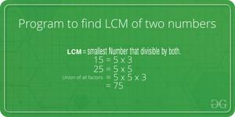

LCM (Least Common Multiple) of two numbers is the smallest number which can be divided by both numbers.

For example, LCM of 15 and 20 is 60, and LCM of 5 and 7 is 35.

A **simple solution** is to find all prime factors of both numbers, then find union of all factors present in both numbers. Finally, return the product of elements in union.

An **efficient solution**is based on the below formula for LCM of two numbers ‘a’ and ‘b’.

a x b = LCM(a, b) * GCD (a, b)  
  
 LCM(a, b) = (a x b) / GCD(a, b)

We have discussed function to find GCD of two numbers. Using GCD, we can find LCM.

Below is the implementation of the above idea:

C++Java

// C++ program to find LCM of two numbers

#include <iostream>

using namespace std;

// Recursive function to return gcd of a and b

long long gcd(long long int a, long long int b)

{

if (b == 0)

return a;

return gcd(b, a % b);

}

// Function to return LCM of two numbers

long long lcm(int a, int b)

{

return (a*b / gcd(a, b)) ;

}

// Driver program to test above function

int main()

{

int a = 15, b = 20;

cout <<"LCM of " << a << " and "

<< b << " is " << lcm(a, b);

return 0;

}

**Output**

LCM of 15 and 20 is 60

***Time Complexity:****O(log(min(a,b))*

***Auxiliary Space:****O(log(min(a,b))*